Hands-Free Healing Study Day 6th February 2021

Via Zoom 10.30 – 4.30/5.00

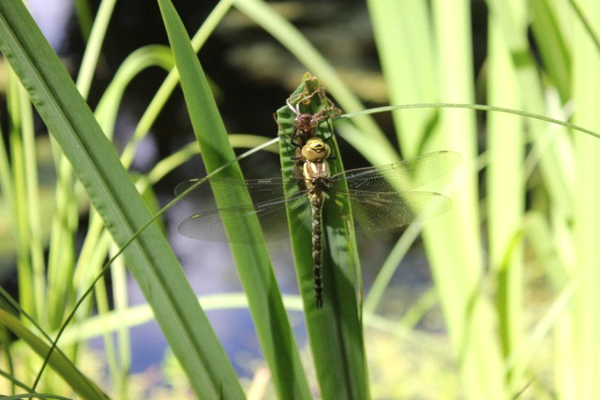

During these unprecedented times when we can’t always be present in the room with our clients, we can still support their health and even enhance our skills by using our CST skills at a distance. Many of us are finding it super effective as well as convenient and a practice we will continue after the pandemic subsides. On this study day Nicky will lay out foundations for you to explore working from a distance using your CST framework.

There are many advantages for clients to distant work -being treated at home is more relaxing and enables them to settle quickly into the session. It is more time efficient for busy people and provides help for people who are 'shielding' or too fragile to travel.

If we need scientific validation, we might go to the realms of Quantum Physics and energetic fields organising matter. Researcher Lynne McTaggart has made a huge contribution in making this accessible in her book The Field. The Heartmath Institute also are leading lights in the area of the electromagnetic fields as organising forces for the body and of course it is the basis of our cranial framework ….. a subtle energetic organising matrix underlying form. Beneath and within the muscle, bone and fluid we are light and energy beings profoundly influenced by other subtle fields such as intention. The day will introduce you to the skills you can bring to working with the subtle rhythmic energetic expression within our client’s anatomy without having your hands on.
During the day we will be addressing basic safety issues, how to ground yourself, setting up and structuring sessions, feeding back etc. Nicky will offer a theoretical framework and practical examples of clinical cases and the day will include individual grounding, small group work and guided practical.

Venue -your own home! The day will take place via Zoom link and advice will be given for those not familiar with this.
Times 10.30 – 4.30 /5.00 . log in from 10.15

Numbers will be limited to 25 to allow an interactive atmosphere

Cost £60

Websites sarahnesling.co.uk or craniosacralsomerset.co.uk

Booking contact Sarah on 07717146419 or at sarahnesling@gmail .com

